PROJECT REPORT

EXPLORING YOUTUBE CHANNELS

1.INTRODUCTION:

1.1 OVERVIEW

Youtube is an American online video sharing and social media platform headqurate in San Bruno, California, United States. Accessible worldwide, it was launched on Feburary 14, 2005, by Steve Chen, Chad Hurley, and Jawed Karim. It is owned by Google and is the second most visited website in the world, after Google search. Youtube has more than 2.5 billion monthly users, who collectively watch more than one billion hours of videos everyday.

1.2 PURPOSE

There are many positive aspects to keep in mind about youtube in comparison to the negatives. By analyzing the positives and negatives of youtube, it is possible to get an idea of the number of users who receive the information and what percentage of them are misleading.

2. PROBLEM DEFINITION & DESIGN THINKING:

2.1 EMPATHY MAP:

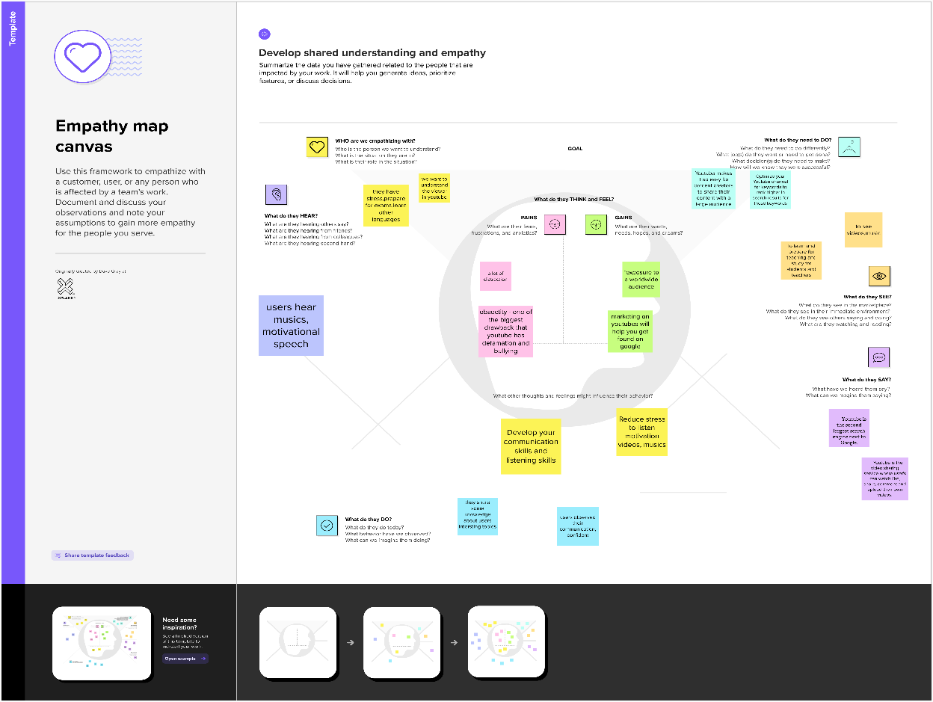

2.2 IDEATION & BRAINSTORMING MAPS:

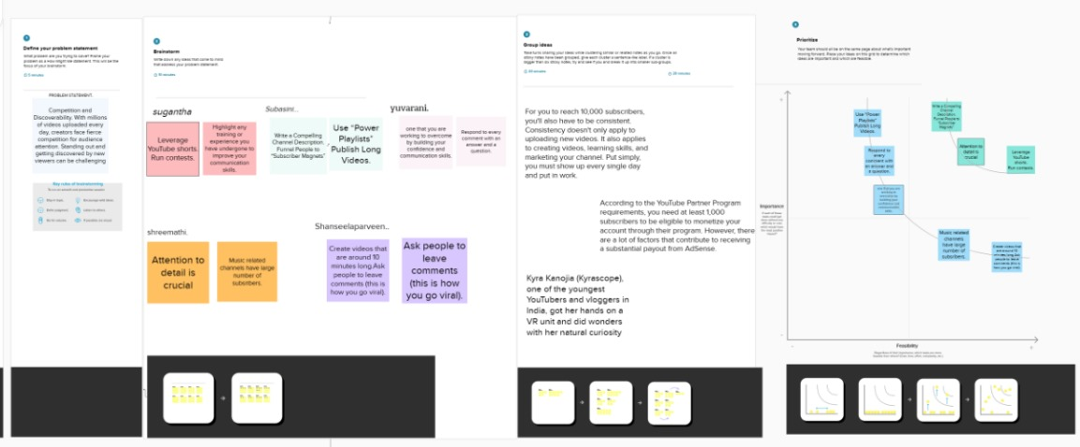

3. RESULT:

In this section, we present the culmination of our exploration into the world’s top youtube channels, shedding light on their subscriber counts, primary languages, and content categories. Our analysis focused on the 50 most-subscribed youtube channels as of February 2023, and the following are the main findings:

3.1 Rank wise channels with subscribers:

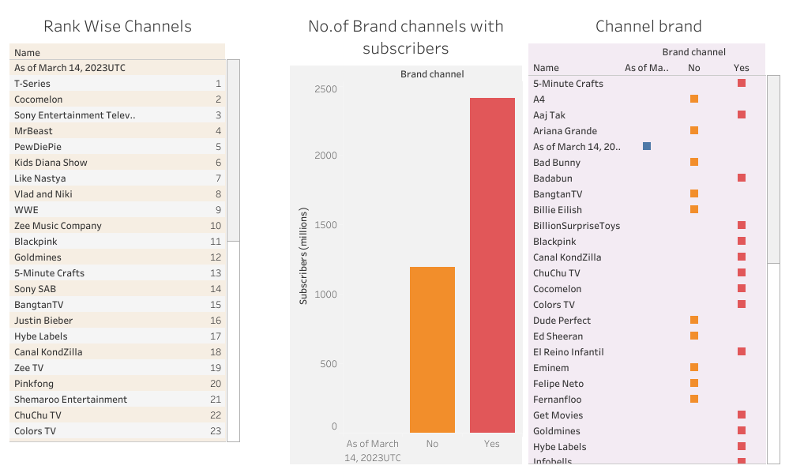

DASHBOARD 1: https://public.tableau.com/views/YoutubeChannelsDashboard1/Dashboard1?:language=en-US&:display_count=n&:origin=viz_share_link

3.2 Channels name and particular languages:

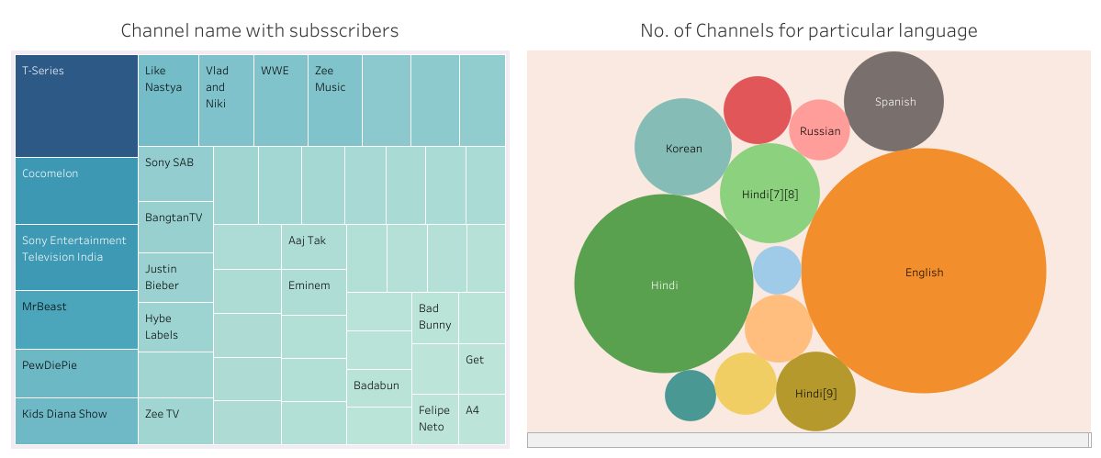https://public.tableau.com/views/YoutubeChannelsDashboard2/Dashboard2?:language=en-US&:display_count=n&:origin=viz_share_link

3.3 Category wise language; Country and language:

https://public.tableau.com/views/YoutubeChannelsDashboard3/Dashboard3?:language=en-US&:display_count=n&:origin=viz_share_link

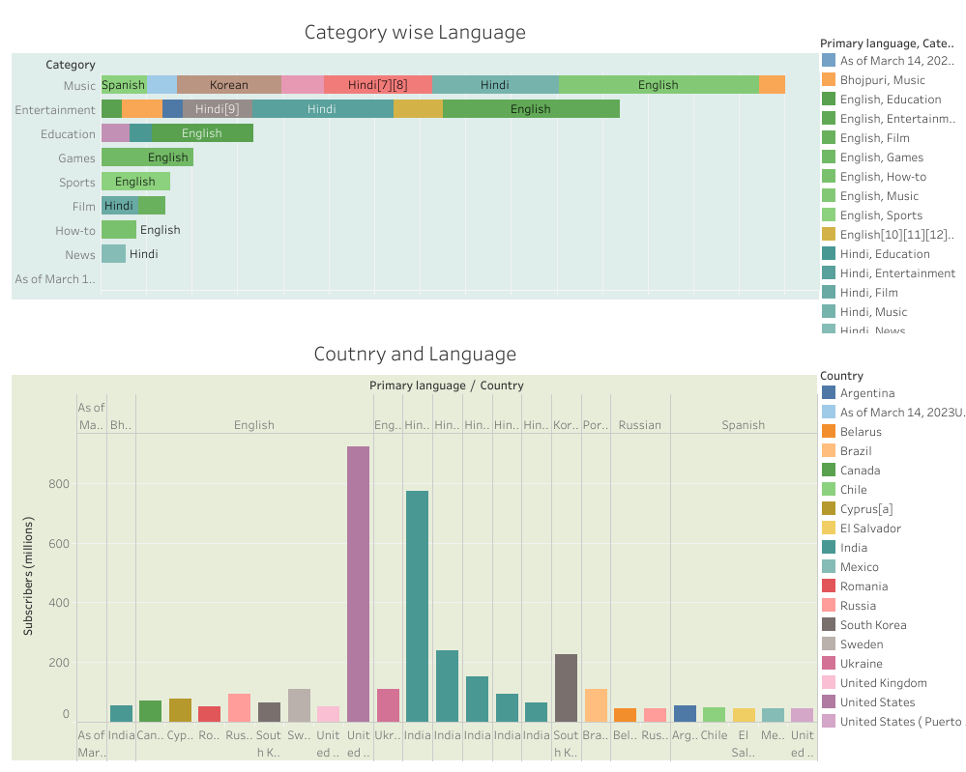

3.4 Language wise subscribers and country wise subscribers:

https://public.tableau.com/views/YoutubeChannelsDashboard4/Dashboard4?:language=en-US&:display_count=n&:origin=viz_share_link

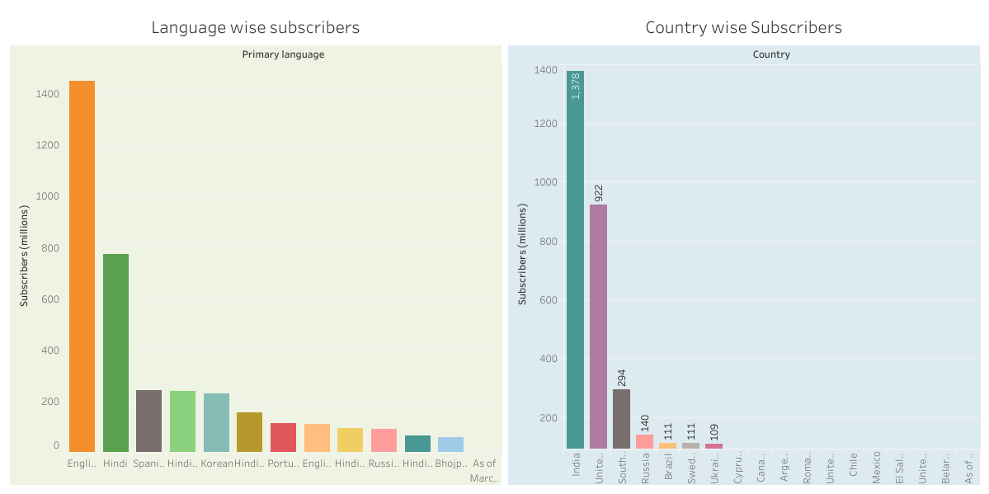

3.5 Story:

https://public.tableau.com/views/YoutubeChannelsstory/Story1?:language=en-US&:display_count=n&:origin=viz_share_link

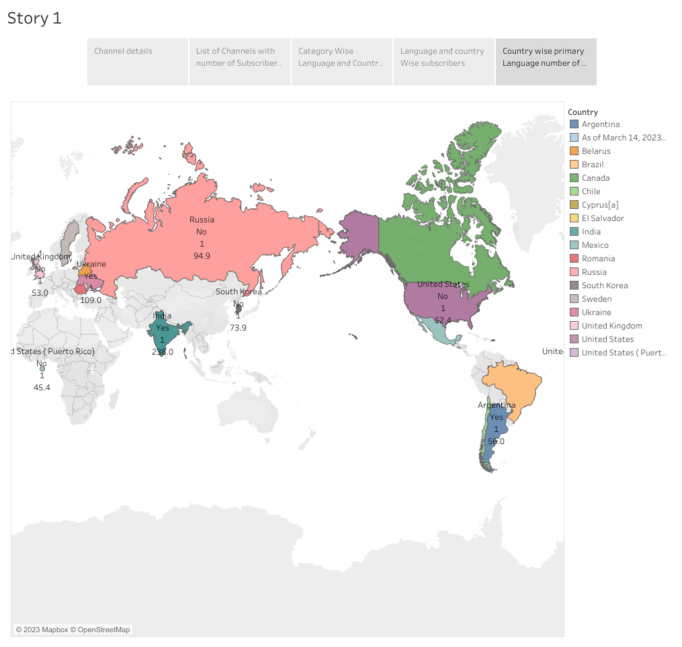

4. ADVANTAGES & DISADVANTAGES:

ADVANTAGES:

* Youtube as an information disseminating platform for students.
* From pet lovers to homemakers, anyone can find content suitable to their interests.
* Youtube videos have been an effective branding method for many businesses.
* You can make money through your youtube channel after it has reached the point of eligibility.
* It is not necessary to invest in Expensive equipment or accessories.
* It is the perfect place to learn and gain expertise.
* With online videos and “How to do” tricks, gaining knowledge is simple.

DISADVANTAGES:

* There are some distinct disadvantages of watching youtube videos, which include a lot of commercials.
* Distraction is one of the most common disadvantages of youtube for drivers, students, or even workers.
* The amount of people uploading videos has grown in the past five years, and it’s becoming challenging for parents, as well as youtube, to review the content.
* Since youtube is a no-cost and accessible platform for anyone, children are attracted to watching videos with explicit language and obscenity
* Many users misuse the platform to spread hate and chaos via content, causing tension between users.
* Making money by creating youtube channels is not that easy.

5. APPLICATIONS:

* Give the Audience more content.
* Youtube allows users to like and comment on content on the platform.
* Youtube is a website designed to share videos online.
* Some youtube videos increase awareness of social issues such as bullying, suicide and LGBT issues.
* It allows broadened social contact especially important for the elderly or mobility impaired.
* It helps to overcome stereotypes of minorities and minority viewpoints.

6. CONCLISION:

In conclusion, this project provided valuable insights into the top Youtube channels, their subscriber counts, primary languages, and content categories. Understanding the Youtube landscape is essential for creators and marketers to thrive in the digital content space.

7. FUTURE SCOPE:

Future enhancements for this project could include:

* Real- time data analysis.
* Predictive analysis for channel growth.
* In-depth analysis of specific content categories.